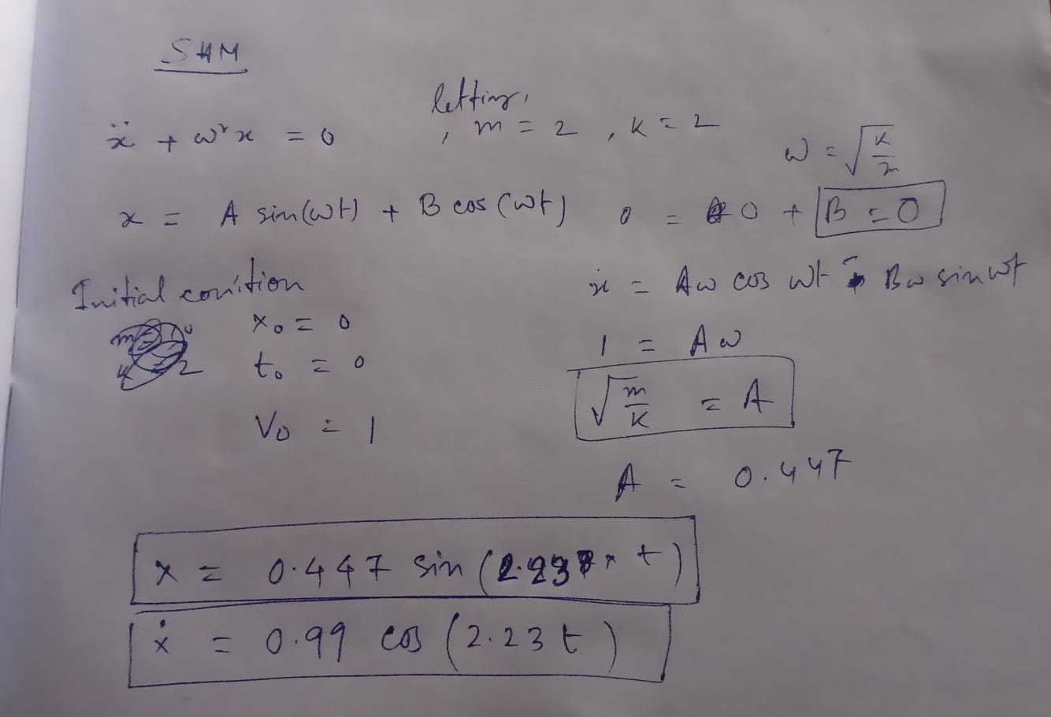
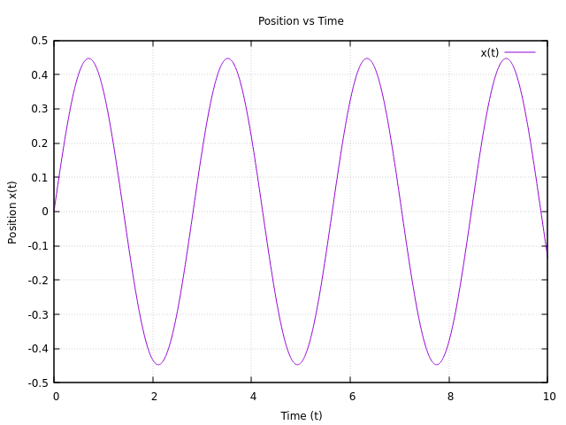
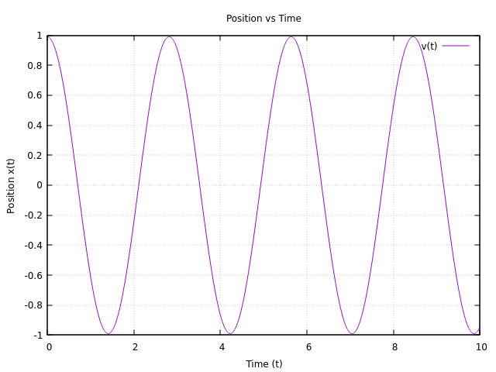
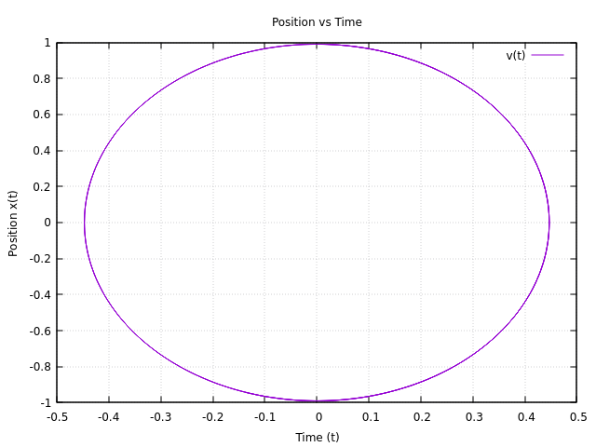
Analytic method:

PROGRAM shm
IMPLICIT NONE

! Variables
REAL :: m, k
REAL :: t, x, v
REAL :: k1x, k2x, k3x, k4x
REAL :: k1v, k2v, k3v, k4v
REAL :: omega
REAL :: dt
INTEGER :: i, n
REAL :: svec(2)

OPEN(1, file='shm.dat', STATUS='REPLACE')

PRINT *, "Enter t0, x0, v0, m, k: "
READ(*,*) t, x, v, m, k

omega = SQRT(k/m)
dt = 0.01
n = 2000

DO i = 0, n

svec = S(x, v, omega)
k1x = svec(1)
k1v = svec(2)

svec = S(x + 0.5*dt*k1x, v + 0.5*dt*k1v, omega)
k2x = svec(1)
k2v = svec(2)

svec = S(x + 0.5*dt*k2x, v + 0.5*dt*k2v, omega)
k3x = svec(1)
k3v = svec(2)

svec = S(x + dt*k3x, v + dt*k3v, omega)
k4x = svec(1)
k4v = svec(2)

WRITE(1, '(F10.4, 1X, F10.4, 1X, F10.4)') t, x, v

t = t + dt
x = x + (k1x + 2.0*k2x + 2.0*k3x + k4x)*dt/6.0
v = v + (k1v + 2.0*k2v + 2.0*k3v + k4v)*dt/6.0

END DO

CLOSE(1)

CONTAINS

FUNCTION func(x, omega) RESULT(d2xdt2)
REAL, INTENT(IN) :: x, omega
REAL :: d2xdt2

d2xdt2 = - omega**2 * x
END FUNCTION func

FUNCTION S(x, v, omega) RESULT(State)
REAL, INTENT(IN) :: x, v, omega
REAL :: State(2)

State(1) = v
State(2) = func(x, omega)
END FUNCTION S

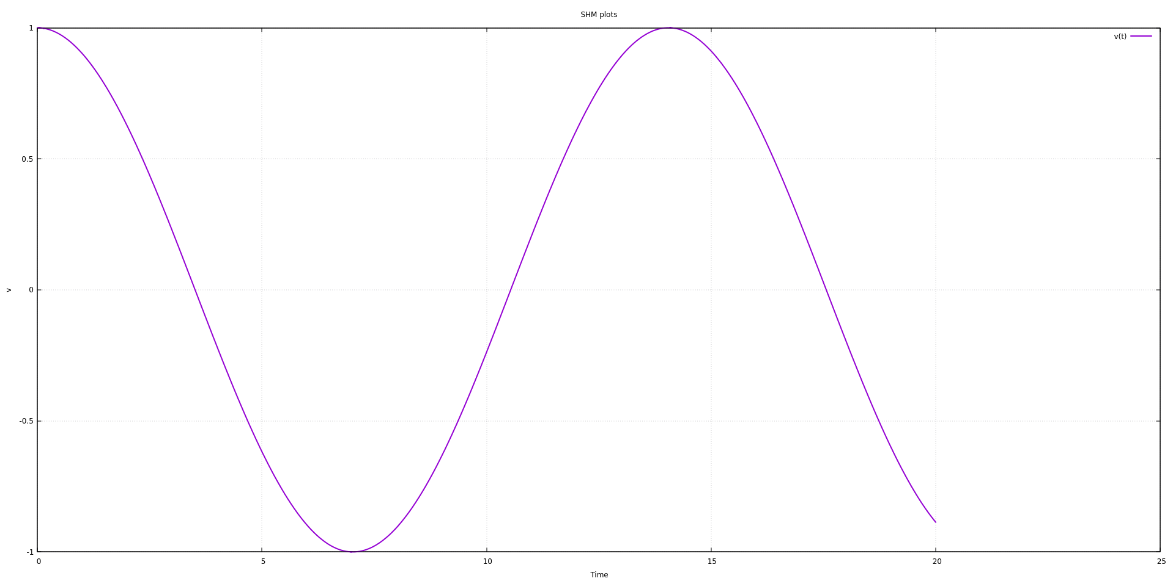
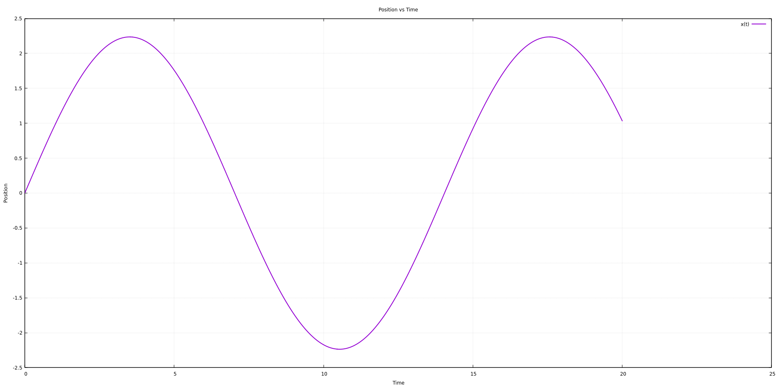
END PROGRAM shm
